# Events Service

Your task is to create events service producer application which serves stringified json to consumer. Communication protocol between producer and consumer should be HTTP.

The data models server by the producer will be events, markets and selections:

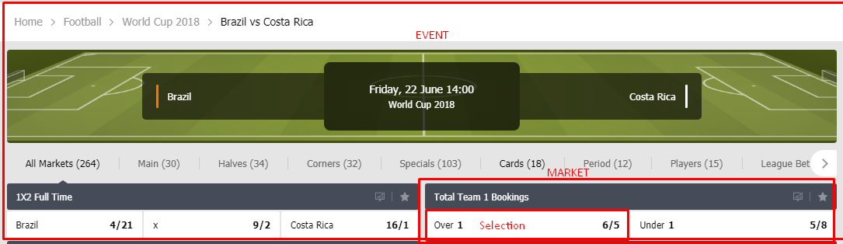

Every event has:  
Id, Name(Brazil vs Costa Rica), StartDate(Fridday 22 June 14:00), SportName(Soccer), LeagueName(World Cup 2018),Status(Prematch/Live/Finished) , collection of markets

Every Market has:

Id, Name(Total Team 1 Bookings), collection of selections

Every Selection has:  
Id, Name(Over 1), Odds(6/5), IsSuspended(whether is possible to bet or not on this selection)  
  
Api endpoints:  
localhost:{port}//events/GetAllEvents – only events, without collection of markets and selections

localhost:{port}//events/GetFullEvents – event with all related markets and selections

localhost:{port}/events/GetEvent/{id} - only event, without collection of markets and selections

localhost:{port}/events/GetFullEvent/{id}– event with all related markets and selections

Implementation details:

* Create individual caches for Events, Markets and Selections which are updated on individually set interval
* Populate and update caches(in a thread safe manner) from in memory repository.
* Generate random data in the repository. Use it for initial load of caches and update randomly the data on the interval property of the cache
* Create asynchronous service for serving all events related data
* Enable CORS